


Installation and Configuration Guide
Spotter Global Radar [VERSION]
Last update date: 25 Mar 2025

CONNECTOR DETAILS
Manufacturer | Spotter Global
Product name | Radar
Product category | Other
Connector Package Name | Evbg.CC.Driver.SpotterGlobal.Radar.Version.[FULLVERSION].ipscdriver
Connector version | [VERSION]
Supported Hardware
SDK/API version
Supported Control Center Version | 5.x
Tested against | [Control Center version range]
License Type | Other

www.everbridge.com

Contents
1 Installation Steps 3
1.1 Connector Installation 3

Installation Steps

Connector Installation
- Open Control Center.
- Click the System tab
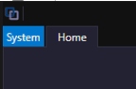
- Click System Configuration
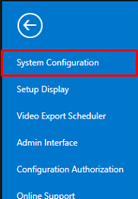
- Inside system configuration toolbox, click Drivers & Extensions
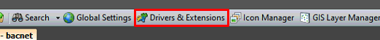
- Once the Drivers & Extensions tab opens, the toolbox will change. Select the option Install.
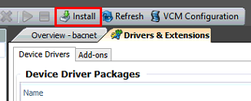
- Select the connector package and click open.
- Wait for the installation to complete without error messages.
- Once the connector is installed, a Server device will need to be created. That can be done by right clicking in System Configuration and going to New -> Device On -> Desired Connection Manager.
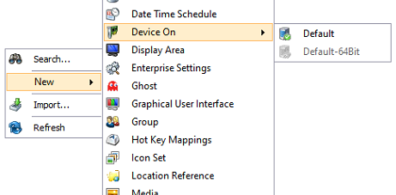
- Add device wizard will pop up. Please select the server device from the list.
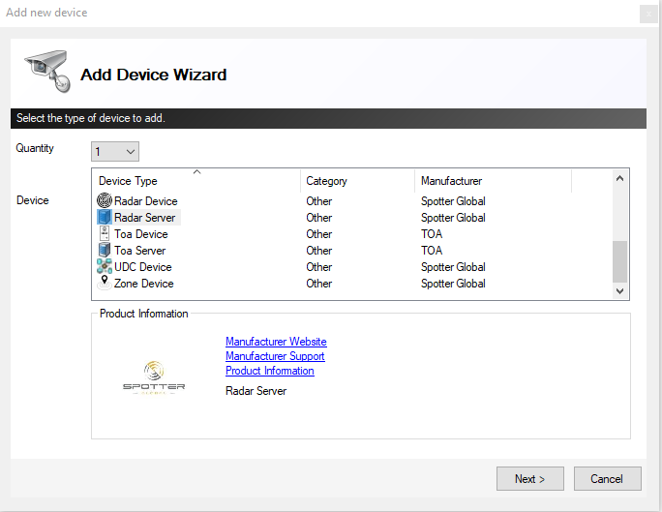
- In the next screen a list of device properties will be visible. They need to be set before the device is created.
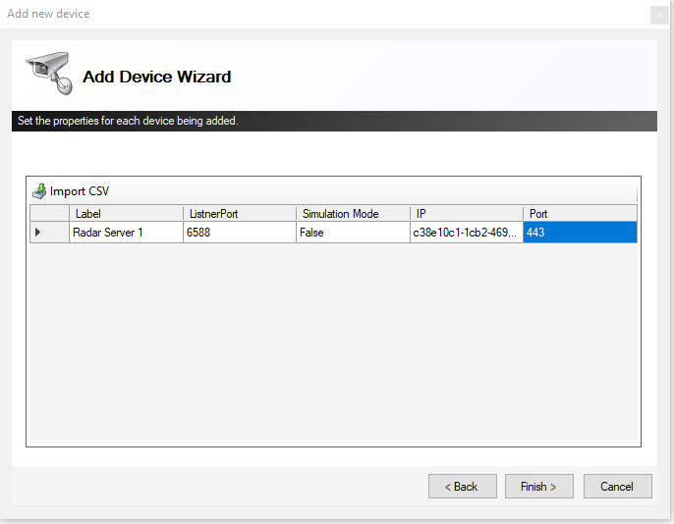
- Here is a breakdown of the properties:
  - ListnerPort – Example Property for Server
  - Simulation Mode – When true, the connector simulates the subsystem instead of connecting to a real one.
  - IP – The IP address for the device.
  - Port – The port the device listens on.

